**Being an Owner at Warwick**  
  
Questions & Answers for Owners  
  
Please note:   
Owners who entered their horse but did not declare, holders of ROA badges and privileges will not be able to attend this day in the complimentary fashion they normally would due to capacity restrictions.

The same rule applies for TBA, NTF, RCA and other metal badge holders.   
  
***This information relates to owners with runners on the day only.***  
**How many badges will I receive?**Six badges have been allocated to each runner.

**Is it the same for partnerships and syndicates?**Yes, single, partnership, syndicate and racing club-owned horses will hold an entitlement of 6 badges.  
  
**Will more badges become available if the 200 are not allocated?**  
The racecourse will use its discretion on this closer to the time. If you wish to leave a request for additional tickets, then please call the racecourse on 01926 405565. Please note we cannot of course, guarantee we will have any available. Our Owner’s Liaison team will contact you by 6pm the night before the race meeting if we have tickets to distribute. No additional passes will be distributed after that time including on race day.   
  
**How do I inform the racecourse what owners are attending to watch the horse?**  
It is vitally important, more so now than ever before, because of the likely processes associated with Test and Trace, that owners attending our race day must enter all their details correctly into the Pass System. This has to be done by 4pm the day before racing.   
  
**What if an Owner has been registered to attend on the Pass System and then can’t attend and another owner wishes to attend in his/her place?**

If it is before 4pm the day before racing, please make the change in Pass System, after that time please call the racecourse on 01926 405565. No changes can be made after 10.00am on race day. Please also note that no changes can be accepted on the day at the Owners window.

**Race Day Arrival – Where Do I Park?**  
Unfortunately the Hampton Street Car Park, which is our traditional Owners Car Park is not available at this pilot meeting because it is part of the Green Zone. Instead owners will be directed to the main entrance on “Bread and Meat Close”. The front rows of our public car park have been reserved exclusively for owner’s usage. Please note it is on a grass surface.

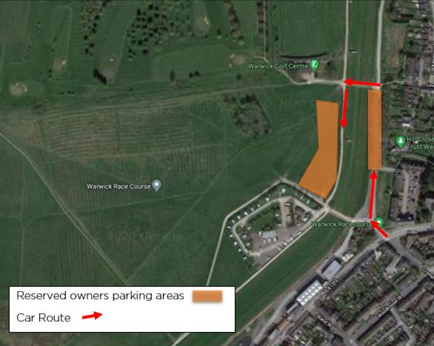 **Where Do I Pick Up My Badges?**  
Owners are asked to present themselves at the Owners Window, where you will be greeted by our Owners Liaison Team and issued with your badges.

**Do I need to take ID?**  
Normally we don’t require our owners to show ID at the entrance. However, with Test and Trace, and the unique nature of the situation, we may require owners/badge holders to show ID, so please bring it with you.  
  
**Will my temperature be taken and will I be asked health related questions at the entrance?**  
At BCD race meetings owners have to have completed an e-learning course on Covid 19, and complete a health assessment.   
  
We will still require this to be undertaken, the reason being that owners are most likely to come in closer contact with members of the Green Zone. Temperature checks will be undertaken.   
  
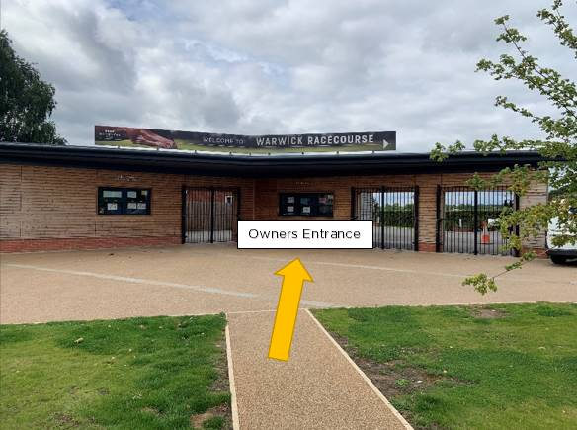  
  
 **Is there any Owner Only areas or rooms?**  
Owners with badges will have access to the Chandler’s Grandstand, our traditional owner’s enclosure. Because the maximum capacity of all rooms at the racecourse have been reduced we are providing additional space for owners in a marquee outside the front of Chandlers.

**Will there be refreshments?**

Food and refreshments will be available in both Chandlers area. The marquee will just contain seating.   
  
  
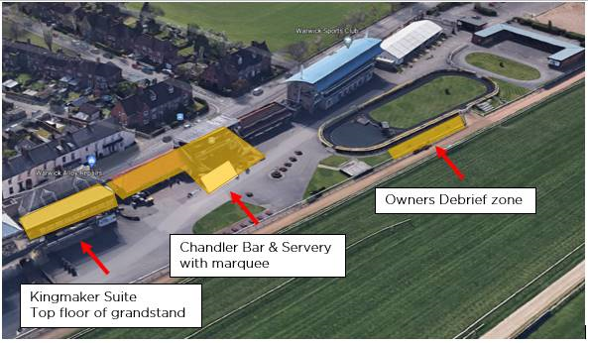

**Can I buy an alcoholic beverage?**  
Yes, absolutely. And as usual we will be offering all our owners a 20% discount on all bottles of wine. There will be a bar in Chandlers with table service in operation.  
  
**Where can I speak to my trainer and jockey?**  
We have created an area next to the Parade Ring that is reserved for owners to talk to their trainers and jockeys in a safe, socially distanced environment. This is identified as the Owners Debrief Zone.  
  
**Will there be Best Turned Out?**  
Yes. These will take place in the Green Zone, where our BTO judge will identify the winner of the BTO and present the groom with a prize.

**Will there be presentations to winning owners?**  
Yes. These will take place outside the Coronation Club not in the Parade Ring. The Coronation Club is located next to the Parade Ring. One of our committee will present a memento to a single representative of the winning owners.

**Will winning Owners be invited for a celebratory drink?**  
Yes. A maximum of six owners will be invited in to the Coronation Club for a celebratory drink in the company of some of our committee. We will present you on the day with a special TV-in-a-card replay of your horse’s success. Following the race day we will send you a special photo as a reminder of your successful day at Warwick Racecourse.  
  
  
More Information  
If you have any questions at all in regards to above please do not hesitate to contact us on 01926 405 565 or email; warwick@thejockeyclub.co.uk